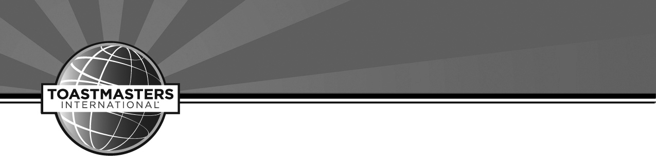

District 19 Business Meeting Program and Agenda

November 15, 2013

Waterloo, Iowa

1. Call to Order
2. Inspirational Thought
3. Reading of the Mission of the District
4. Welcome
5. Meeting Appointments
6. Credentials Committee Report
7. Adoption of the Agenda
8. Report of Minutes from Previous Meeting
9. Confirmation of Appointed District Officers
10. Special Order: Adoption of District Budget 2014-2015
11. Senior Officer Reports:
    1. District Governor Report
    2. Lieutenant Governor of Education and Training Report
    3. Lieutenant Governor Marketing Report
    4. Public Relations Officer Report
    5. Treasurer Report
    6. Division Governor Reports:
       1. Division A Governor Report
       2. Division B Governor Report
       3. Division C Governor Report
       4. Division D Governor Report
       5. Division E Governor Report
12. Standing Committee Reports
    1. Audit Committee
13. New Business
    1. Spring 2015 Conference Date & Location
    2. Fall 2015 Location
14. Announcements
    1. Date and Place of next District Council Meeting
15. Adjournment