Patriotic Action with Toastmasters!
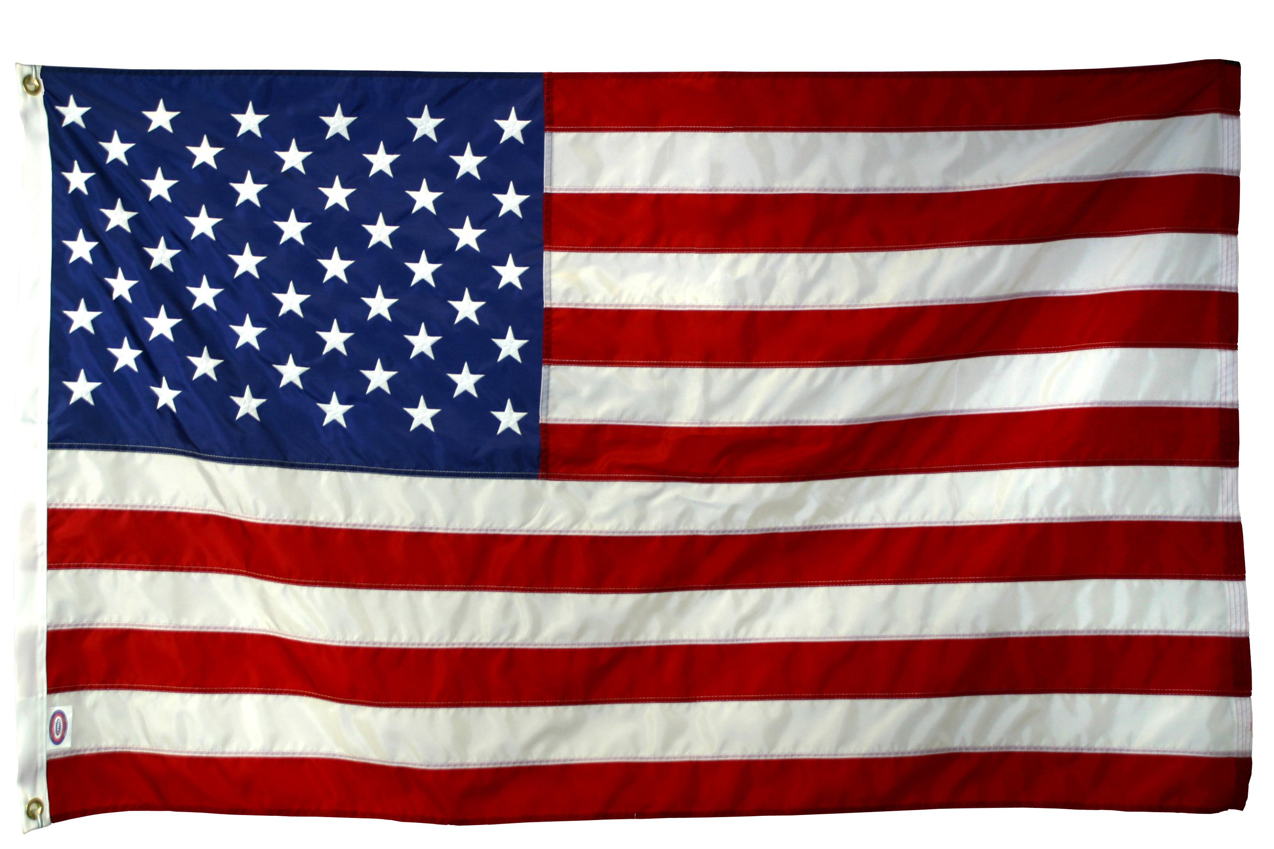
Free meal - Bring a friend
See what Toastmasters is all about!

When: Monday June 29th at 6:30pm -8pm
Where: Okoboji Grill South
6050 SE 14th St. DSM, IA

